Pazuru

SOFTWARE analysis

document

**Version history**

|  |  |  |  |
| --- | --- | --- | --- |
| **Version** | **Date** | **Changes** | **Author[1]** |
| 0.01 | 08.05.2019 | Document created with Introduction, Requirements and empty Use cases. | Lucassen, Mario M. M.lucassen@student.fontys.nl |
| 0.02 | 09.05.2019 | Updated the Introduction added User Interface | Lucassen, Mario M. M.lucassen@student.fontys.nl |
| 0.03 | 10.05.2019 | Added use case diagram, use cases, interfaces and architectural analysis. | Lucassen, Mario M. M.lucassen@student.fontys.nl |
| 1.00 | 10.05.2019 | Final version of document. | Lucassen, Mario M. M.lucassen@student.fontys.nl |

**Table of contents**

1. Introduction 4

1.1. Purpose 4

1.2. Scope 4

1.3. Author Profile 4

2. Requirements 5

2.1. Actions 5

2.2. Rules 5

2.3. Quality attributes 6

3. Use cases 7

3.1. Use case diagrams 7

3.2. Use case descriptions 8

3.2.1. Select puzzle 8

3.2.2. Select solver 11

3.2.3. Generate puzzle 14

3.2.4. Solve puzzle 16

3.2.5. Execute move 18

3.2.6. Undo move 25

3.2.7. Verify puzzle 27

3.2.8. Describe puzzle 30

3.2.9. Show solved puzzles 32

3.2.10. Filter solved puzzles 34

4. User interface specification 38

4.1. Home page 38

4.2. Previously solved puzzles page 39

5. Architectural analysis 40

5.1. System overview 40

5.1.1. Client 40

5.1.2. Server 40

5.1.3. REST API 40

5.2. Analysis object model 40

Table 1. Global definitions.

|  |  |
| --- | --- |
| Name | Description |
| Enigmatologist | Someone who studies and writes mathematical, word or logic puzzles. |
| Fontys | Fontys University of Applied Sciences. |
| Canvas | A portal for students to submit their work to. |

# Introduction

## Purpose

For the course Software Engineering, at the Fontys University of Applied Sciences, in the third semester the assignment Big Idea is to create a distributed application. I have chosen to create a puzzle platform. The platform is intended for Enigmatologists to play around with logic puzzles. A move system for executing and undoing a move will be used to play puzzles, the enigmatologist will be able to verify the current puzzle state to check whether his or her attempt is correct. Not only will the platform support playing puzzles but also generating new ones, solving puzzles and give descriptions for puzzle strategies and rules. All previously solved puzzles will be saved and shown on a previously solved list page that can be filtered by puzzle type. The puzzles that this platform will support are Sudoku and Hitori. For Sudoku, a backtracking algorithm will be used for solving the puzzle. And Hitori will be solved using solving techniques described in the Hitori specification document.

This idea is accepted by the assessor of the course, Kuijpers, Nico N.H.L. in a concept document submitted on Canvas on 14.04.2019.

## Scope

The scope of the product being made is something new and thus not a subsystem, but does include puzzles as subsystems. The scope also establishes boundaries of the requirements and identify features/requirements outside and inside of the scope.

|  |
| --- |
| Scope includes |
| Requirements that are listed with an importance level of ‘Must’, ‘Should’ or ‘Could’ in chapter 2, Requirements. |
| Sudoku (subsystem) |
| Hitori (subsystem) |

|  |
| --- |
| Scope excludes |
| Due to time constraints, not all requirements will be made. Requirements that are listed with an importance level of ‘Wont’ will not be included in the release product. |

## Author Profile

The author of the puzzle platform is Lucassen, Mario M, a Software Engineering student at Fontys. The product will be developed at the Fontys University of Applied Sciences, Rachelsmolen 1 in Eindhoven during the time allotted for the Software Engineering course.

|  |  |  |  |
| --- | --- | --- | --- |
| Author information |  |  |  |
| Name: | Lucassen, Mario M. | Course: | Software Engineering |
| Email: | M.lucassen@student.fontys.nl | Role: | Software Developer |

# Requirements

The requirements have been composed using the MoSCoW method which can be found in the tables below, under the heading Importance. The actions and rules described here are very generic because that is what this platform is. Each puzzle will be documented separately as a subsystem with its own actions and rules section.

## Actions

The actions for the system are shown in a table with per actions a name, description, importance, urgency and use case ID.

|  |  |  |  |  |  |
| --- | --- | --- | --- | --- | --- |
| ID | Name | Description | Importance | Urgency | UC ID |
| F1 | Select puzzle | To select a puzzle. | Must | High | UC1 |
| F2 | Select solver | To select a solver. | Must | High | UC2 |
| F3 | Generate puzzle | To generate a puzzle. | Must | High | UC3 |
| F4 | Solve puzzle | To solve a puzzle. | Must | High | UC4 |
| F5 | Execute move | To execute a move for a puzzle. | Should | Medium | UC5 |
| F6 | Undo move | To undo an executed move for a puzzle. | Should | Medium | UC6 |
| F7 | Verify puzzle | To verify a puzzle state. | Should | Medium | UC7 |
| F8 | Describe puzzle | To describe a puzzle. | Could | Low | UC8 |
| F9 | Show solved puzzles | To show the previously solved puzzle list page | Could | Low | UC9 |
| F10 | Filter solved puzzles | To filter the previously solved puzzle list by puzzle type. | Could | Low | UC10 |

## Rules

The rules for the system are shown in the table with per rule a description, importance, and urgency.

|  |  |  |  |
| --- | --- | --- | --- |
| ID | Description | Importance | Urgency |
| R1 | The puzzle must be playable. | Must | Medium |
| R2 | The puzzle must be solvable. | Must | Must |
| R3 | A puzzle must have at least one rule to be solvable. | Must | Must |

## Quality attributes

The quality attributes for the system are shown in the table with categories used by the ISO 25010[2].

|  |  |  |
| --- | --- | --- |
| ID | Category ISO 25010 | Description |
| Q1 | Performance | The maximum latency is 400ms. |
| Q2 | Performance | The maximum resources that the application can use is not more than 2 GB. |
| Q3 | Performance | The minimum puzzles that can be solved concurrently are 10. |
| Q4 | Compatibility | Documentation describing interfaces is available to show how components communicate. |
| Q5 | Usability | The system can be used by anyone within 10 minutes. |
| Q6 | Reliability | The system has a 99% uptime. |
| Q7 | Reliability | The system is at least 23 hours per day available. |
| Q8 | Security | Any data is securely sent to the server and clients. |
| Q9 | Maintainability | The system is built modularly. |
| Q10 | Maintainability | The source code is written according to the Microsoft code conventions[3] for C# and the Java Code Conventions[4]. |
| Q11 | Maintainability | Source code is documented. |
| Q12 | Maintainability | At least 80% of the source code is covered by tests. |
| Q13 | Maintainability | Each puzzle added to the platform must have its rules and actions documented in a separate document named after the puzzle. |

# Use cases

This chapter contains Use case diagram(s) and Use cases for the platform. All the Use case diagram(s) & Use cases are created with Visual Paradigm using the UML[5] specification standard.

## Use case diagrams

Pazuru Use case diagram.

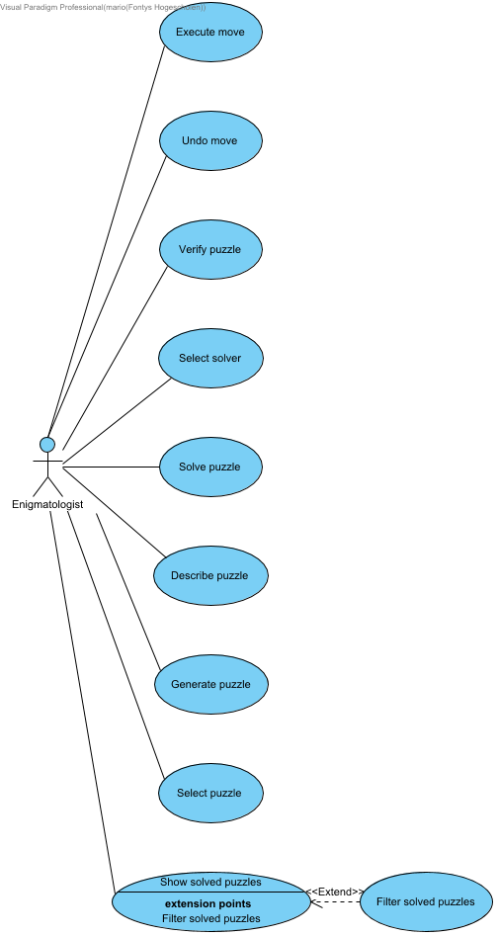

## Use case descriptions

Pazuru Use cases.



### Select puzzle

|  |
| --- |
| Select Puzzle |
| ID | UC1 |
| Description | To select a puzzle. |
| Primary Actors | Enigmatologist |
| Level | User |
| Complexity | Low |
| Use Case Status | Complete |
| Implementation Status | Scheduled |
| Preconditions | The ACTOR is on the home page. |
| Post-conditions | The ACTOR has selected the first puzzle in the puzzle selection. |
| Author | Lucassen, Mario M. |
| Assumptions | At least one puzzle is implemented in the system. |

#### Scenarios

***Happy path***

|  |
| --- |
| 1. The ACTOR clicks on the puzzle select. |
| 2. SYSTEM Displays a list of puzzles. |
| 3. The ACTOR clicks on the first puzzle. |
| 4. SYSTEM Displays the selected puzzle and enables the puzzle solver select. |

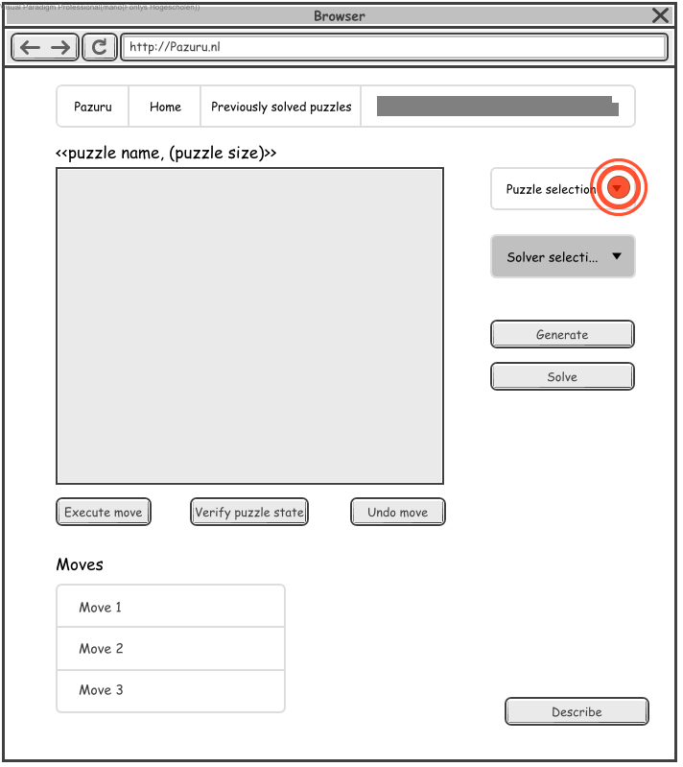

1. The ACTOR clicks on the puzzle select.

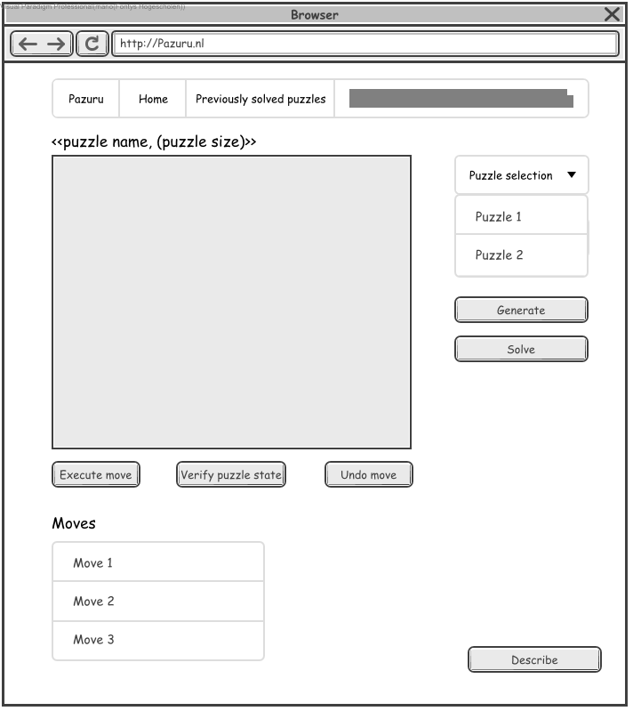

2. SYSTEM Displays a list of puzzles.

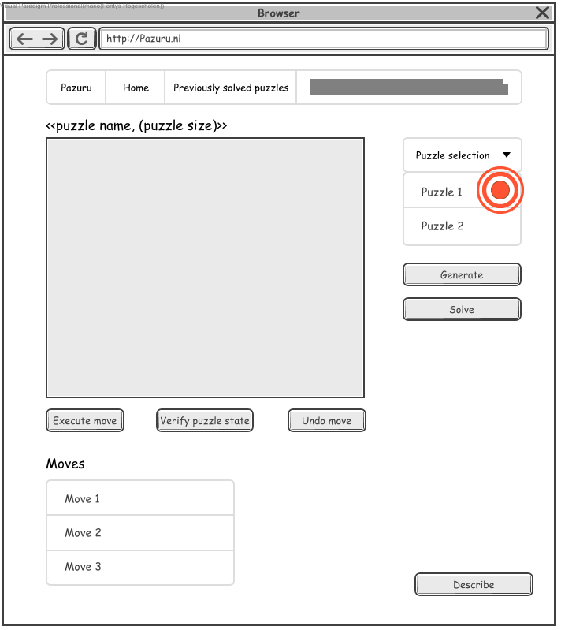

3. The ACTOR clicks on the first puzzle.

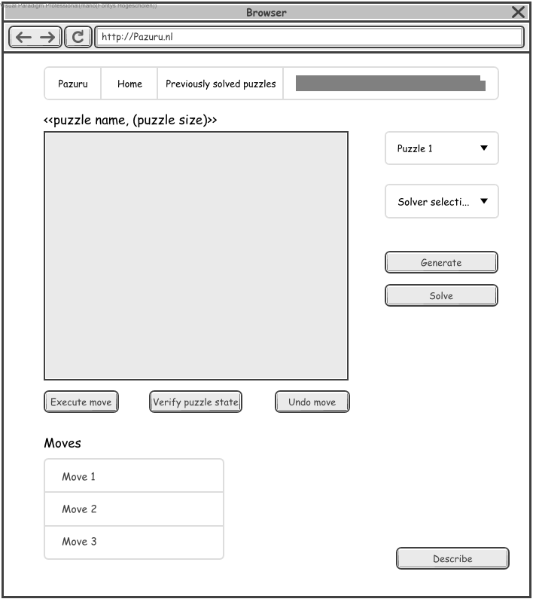

4. SYSTEM Displays the selected puzzle and enables the puzzle solver select.

### Select solver

|  |  |
| --- | --- |
| Select solver |  |
| ID | UC2 |
| Description | To select a solver. |
| Primary Actors | Enigmatologist |
| Level | User |
| Complexity | Low |
| Use Case Status | Complete |
| Implementation Status | Scheduled |
| Preconditions | Select puzzle is successfully executed. |
| Post-conditions | The ACTOR has selected a solver. |
| Author | Lucassen, Mario M. |
| Assumptions | At least one solver is implemented in the system for the selected puzzle. |

#### Scenarios

***Happy path***

|  |
| --- |
| 1. The ACTOR clicks on the solver select. |
| 2. SYSTEM Displays a list of solvers for the selected puzzle. |
| 3. The ACTOR clicks on the first solver. |
| 4. SYSTEM Displays the selected solver. |

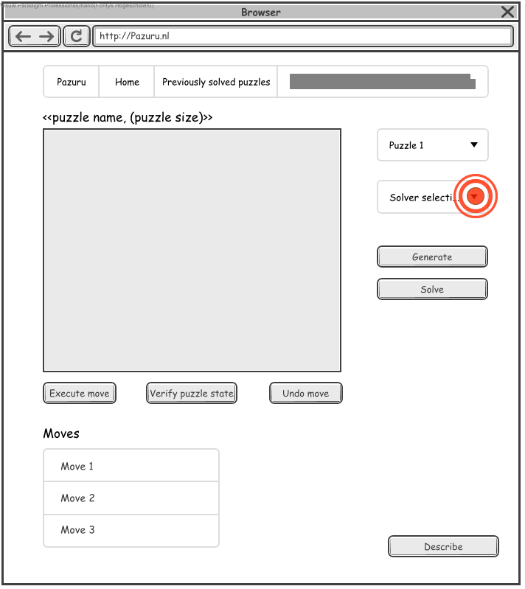

1. The ACTOR clicks on the solver select.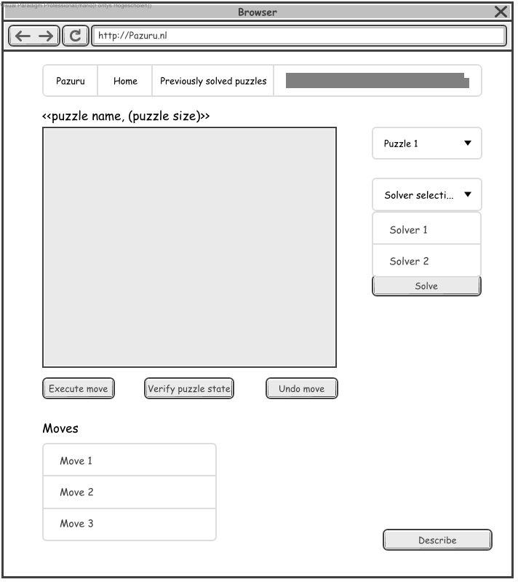

2. SYSTEM Displays a list of solvers for the selected puzzle.

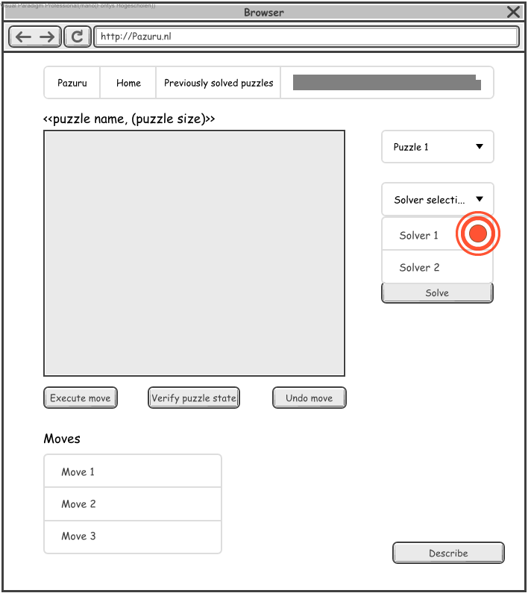

3. The ACTOR clicks on the first solver.

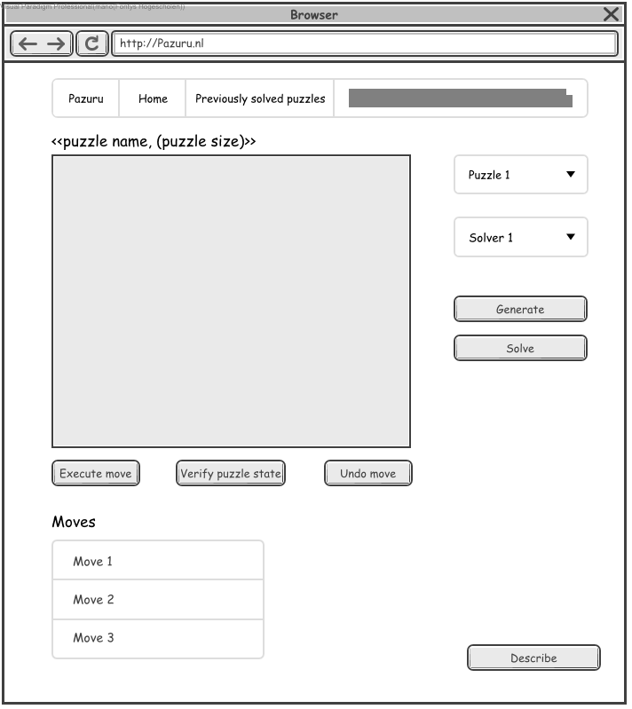

4. SYSTEM Displays the selected solver.

### Generate puzzle

|  |  |
| --- | --- |
| Generate puzzle |  |
| ID | UC3 |
| Description | To generate a puzzle. |
| Primary Actors | Enigmatologist |
| Level | User |
| Complexity | Low |
| Use Case Status | Complete |
| Implementation Status | Scheduled |
| Preconditions | Select solver is executed successfully. |
| Post-conditions | The ACTOR has generated a puzzle. |
| Author | Mario Lucassen |
| Assumptions | N/A |

#### Scenarios

***Happy path***

|  |
| --- |
| 1. The ACTOR clicks on the **Generate** button. |
| 2. SYSTEM Displays the generated puzzle and sets the puzzle name. |

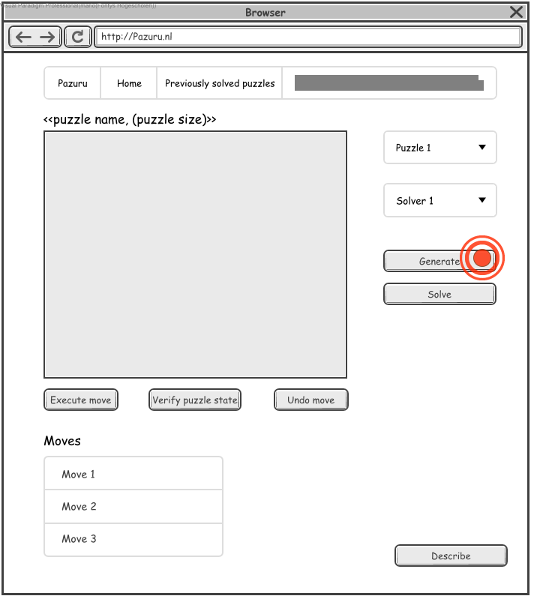

1. The ACTOR clicks on the Generate button.

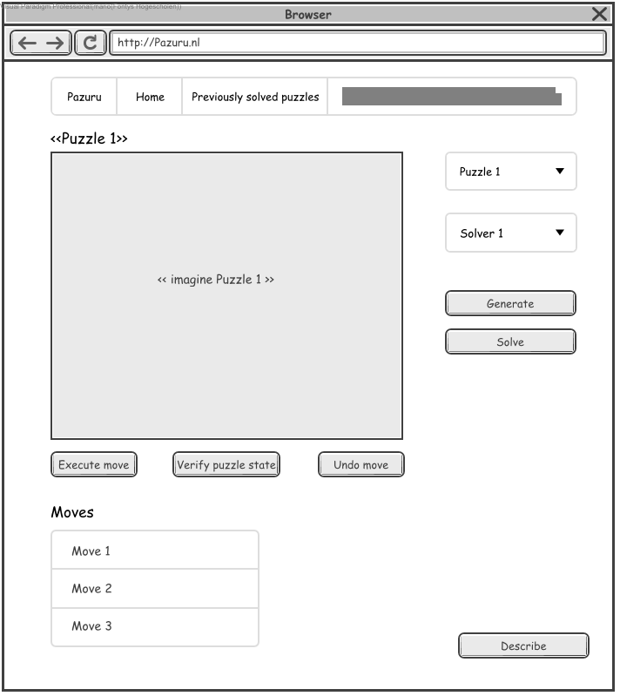

2. SYSTEM Displays the generated puzzle and sets the puzzle name.

### Solve puzzle

|  |  |
| --- | --- |
| Solve puzzle |  |
| ID | UC4 |
| Description | To solve a puzzle. |
| Primary Actors | Enigmatologist |
| Level | User |
| Complexity | Low |
| Use Case Status | Complete |
| Implementation Status | Scheduled |
| Preconditions | Generate puzzle is executed successfully. |
| Post-conditions | The current puzzle is solved. |
| Author | Mario Lucassen |
| Assumptions | N/A |

#### Scenarios

***Happy path***

|  |
| --- |
| 1. The ACTOR clicks on the **Solve** button. |
| 2. SYSTEM Displays the solved puzzle solution. |

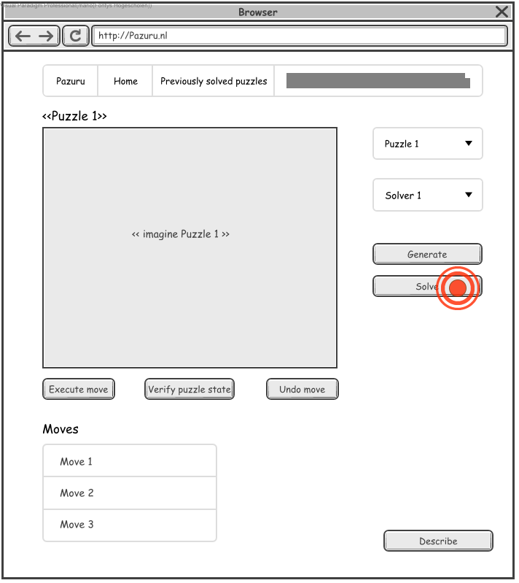

1. The ACTOR clicks on the Solve button.

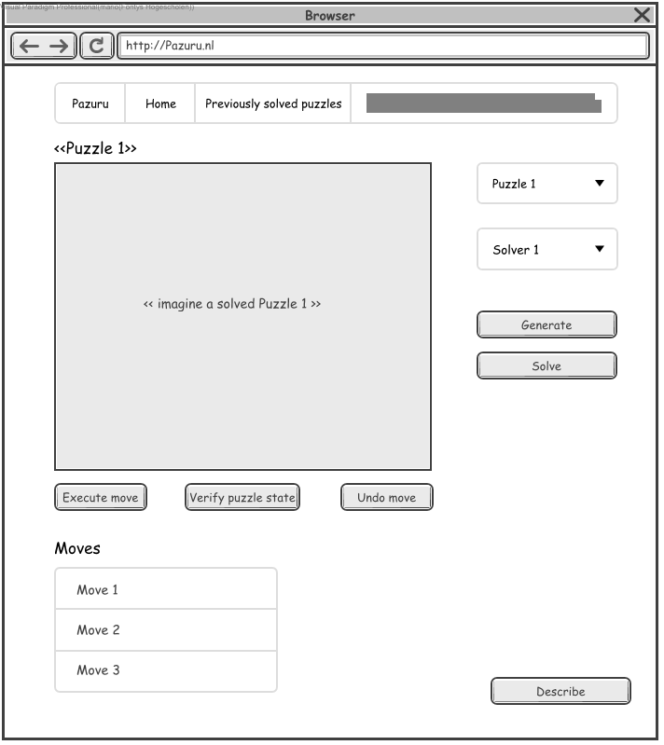

2. SYSTEM Displays the solved puzzle solution.

### Execute move

|  |  |
| --- | --- |
| Execute move |  |
| ID | UC5 |
| Description | To execute a move for a puzzle. |
| Primary Actors | Enigmatologist |
| Level | User |
| Complexity | Medium |
| Use Case Status | Complete |
| Implementation Status | Scheduled |
| Preconditions | Generate puzzle is executed successfully. |
| Post-conditions | The ACTOR has successfully executed a move. |
| Author | Mario Lucassen |
| Assumptions | The ACTOR knows how to perform a move for the selected puzzle. |

#### Scenarios

***Happy path***

|  |
| --- |
| 1. The ACTOR clicks on the puzzle to select a move. |
| 2. SYSTEM Displays that a move is selected. |
| 3. The ACTOR clicks on the **Execute move** button. |
| 4. SYSTEM Performs the executed move, adds the move to the moves list and displays the new puzzle state. |

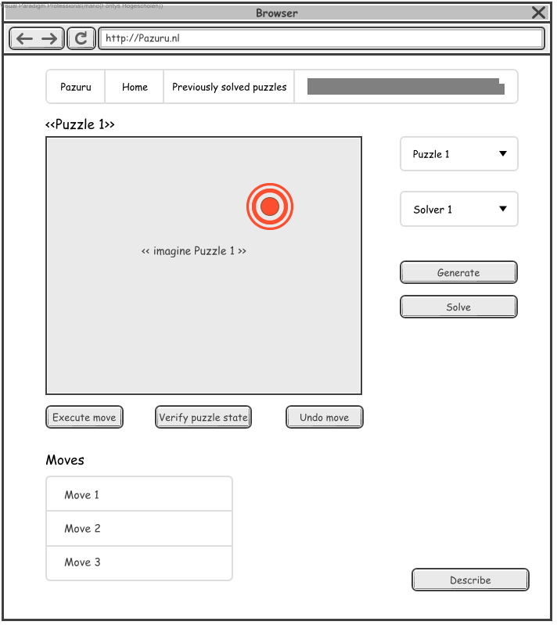

1. The ACTOR clicks on the puzzle to select a move.

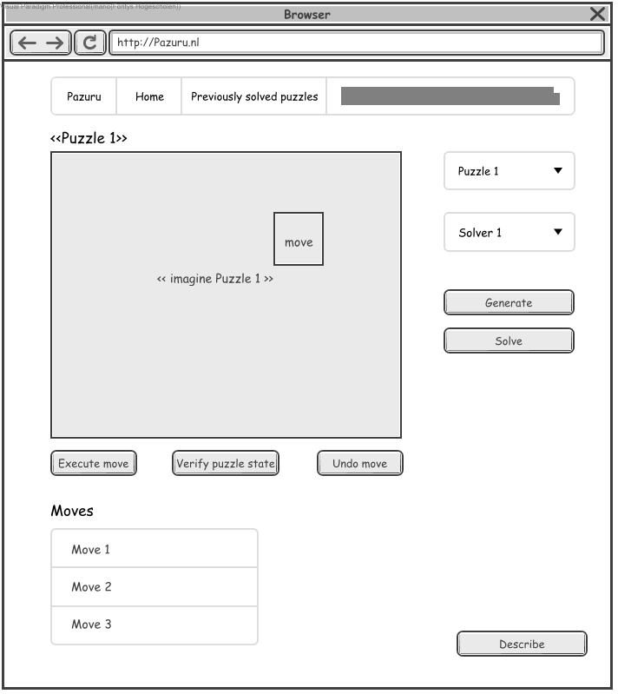

2. SYSTEM Displays that a move is selected.

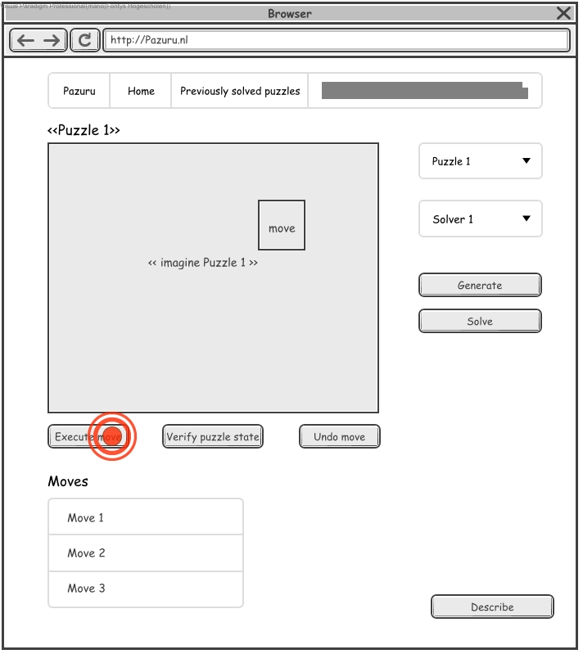

3. The ACTOR clicks on the Execute move button.

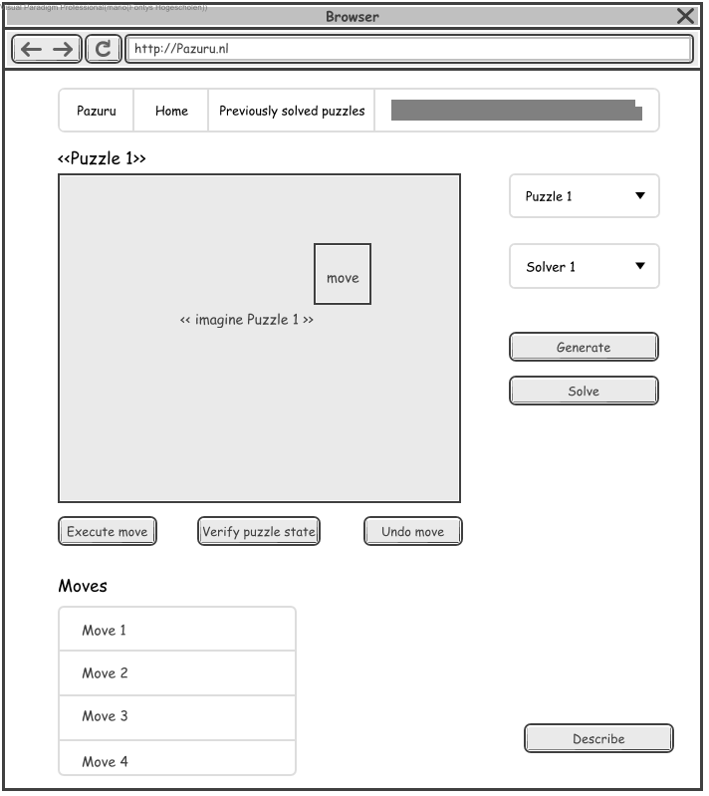

4. SYSTEM Performs the executed move, adds the move to the moves list and displays the new puzzle state.

***Invalid move path***

|  |
| --- |
| 1. The ACTOR clicks on the puzzle to select a move. |
| 2. SYSTEM Displays that a move is selected. |
| 3. The ACTOR clicks on the **Execute move** button. |
| 4. SYSTEM Displays popup message that the move is invalid. |
| 5. The ACTOR clicks on **Ok** button. |
| 6. SYSTEM Removes the popup message and removes the invalid move. |



1. The ACTOR clicks on the puzzle to select a move.



2. SYSTEM Displays that a move is selected.



3. The ACTOR clicks on the Execute move button.

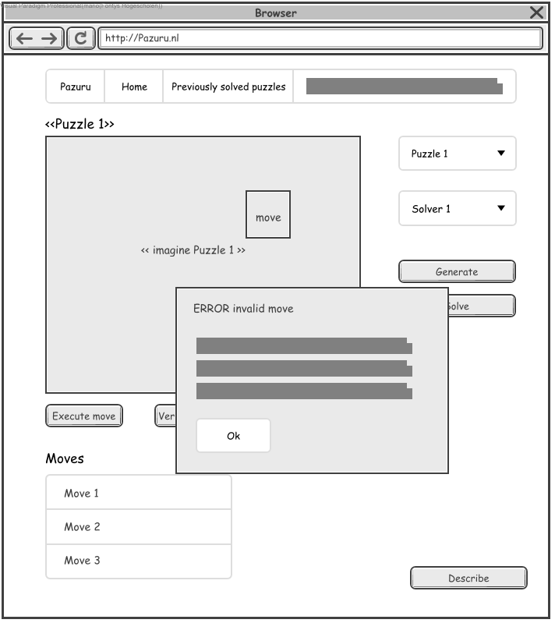

4. SYSTEM Displays popup message that the move is invalid.

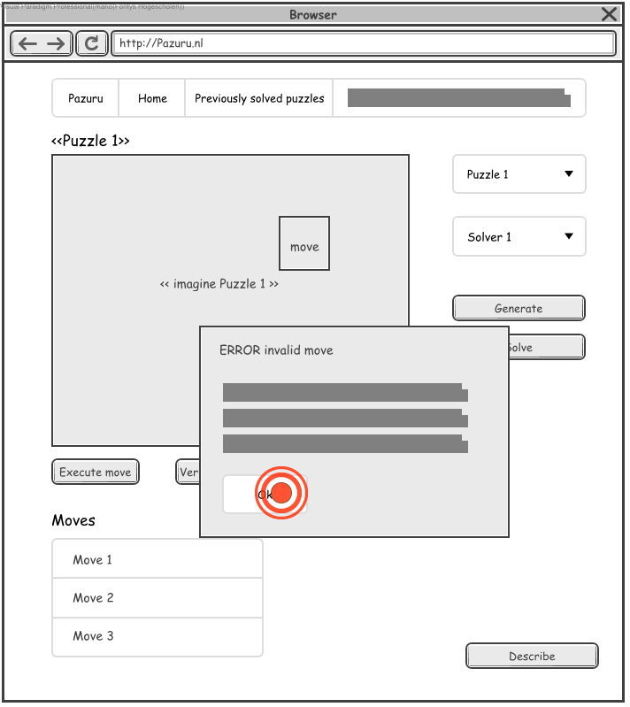

5. The ACTOR clicks on Ok button.

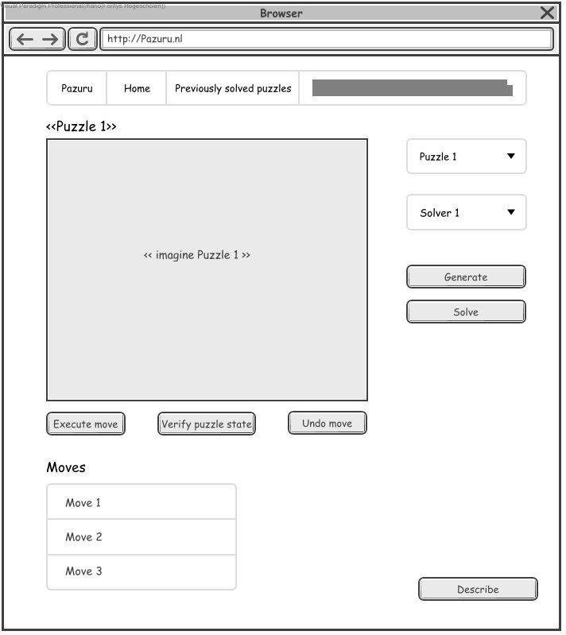

6. SYSTEM Removes the popup message and removes the invalid move.

### Undo move

|  |  |
| --- | --- |
| Undo move |  |
| ID | UC6 |
| Description | To undo an executed move for a puzzle. |
| Primary Actors | Enigmatologist |
| Level | User |
| Complexity | Low |
| Use Case Status | Complete |
| Implementation Status | Scheduled |
| Preconditions | Execute move is executed successfully. |
| Post-conditions | The ACTOR has successfully executed an undo move. |
| Author | Mario Lucassen |
| Assumptions | N/A |

#### Scenarios

***Happy path***

|  |
| --- |
| 1. The ACTOR clicks on the **Undo move** button. |
| 2. SYSTEM Performs the undo move, removes the move from the moves list and displays the previous puzzle state. |

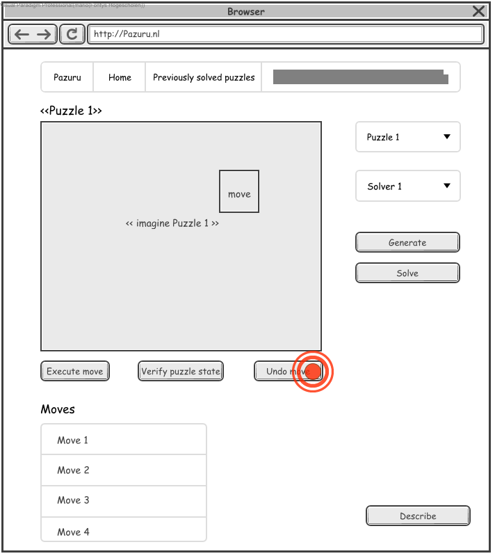

1. The ACTOR clicks on the Undo move button.

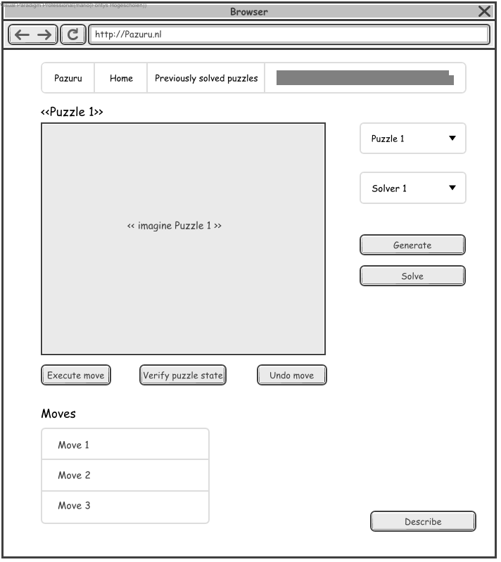

2. SYSTEM Performs the undo move, removes the move from the moves list and displays the previous puzzle state.

### Verify puzzle

|  |  |
| --- | --- |
| Verify puzzle |  |
| ID | UC7 |
| Description | To verify a puzzle state. |
| Primary Actors | Enigmatologist |
| Level | User |
| Complexity | Low |
| Use Case Status | Complete |
| Implementation Status | Scheduled |
| Preconditions | Generate puzzle is executed successfully. |
| Post-conditions | The puzzle state is verified. |
| Author | Mario Lucassen |
| Assumptions | N/A |

#### Scenarios

***Happy path***

|  |
| --- |
| 1. The ACTOR clicks on the **Verify puzzle state** button. |
| 2. SYSTEM Displays a popup with the verification result of the puzzle state. |
| 3. The ACTOR clicks on the **Ok** button. |
| 4. SYSTEM Removes the popup. |

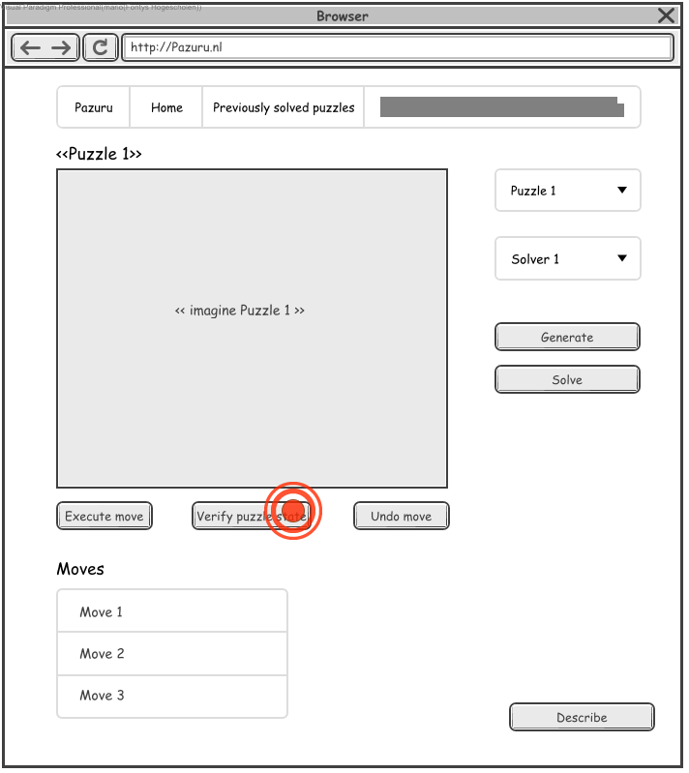

1. The ACTOR clicks on the Verify puzzle state button.

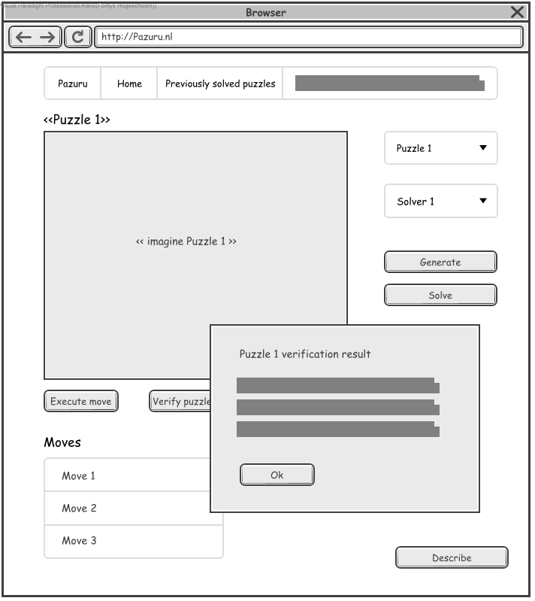

2. SYSTEM Displays a popup with the verification result of the puzzle state.

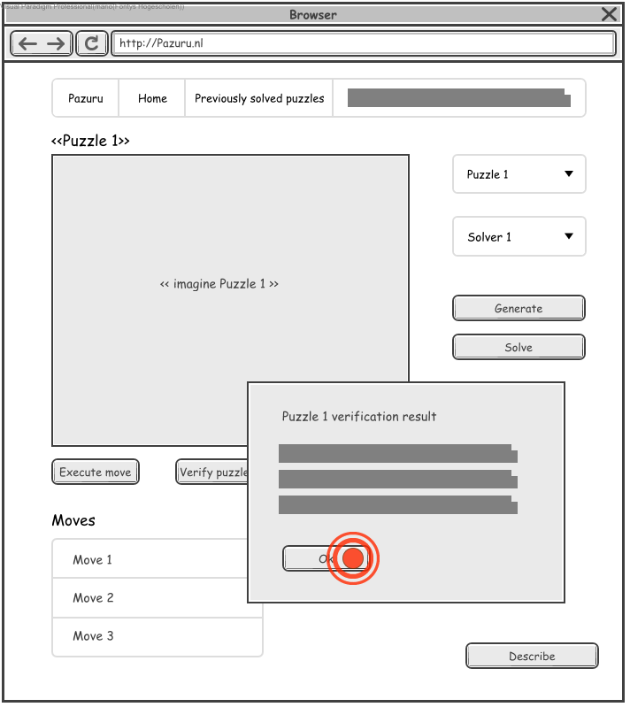

3. The ACTOR clicks on the Ok button.



4. SYSTEM Removes the popup.

### Describe puzzle

|  |  |
| --- | --- |
| Describe puzzle |  |
| ID | UC8 |
| Description | To describe a puzzle. |
| Primary Actors | Enigmatologist |
| Level | User |
| Complexity | Low |
| Use Case Status | Complete |
| Implementation Status | Scheduled |
| Preconditions | The ACTOR is on the Home page. |
| Post-conditions | The ACTOR has the popup that describes the puzzle open. |
| Author | Mario Lucassen |
| Assumptions | N/A |

#### Scenarios

***Happy path***

|  |
| --- |
| 1. The ACTOR clicks on the **Describe** button. |
| 2. SYSTEM Displays a popup that describes the puzzle. |

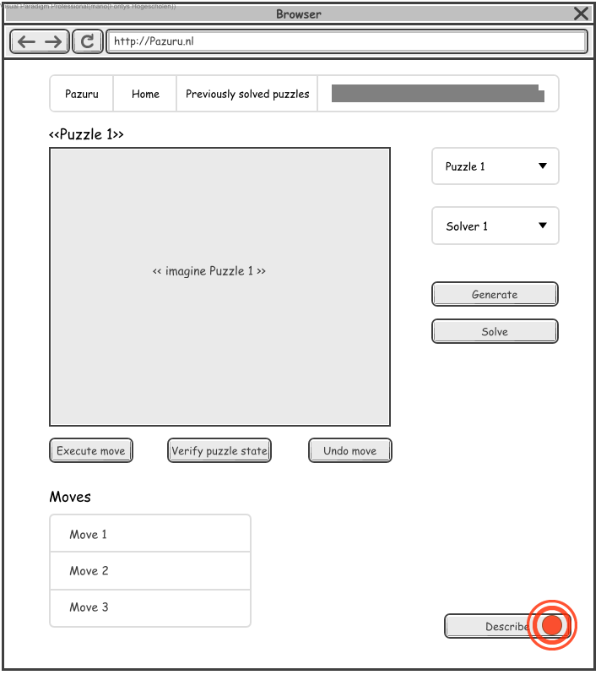

1. The ACTOR clicks on the Describe button.

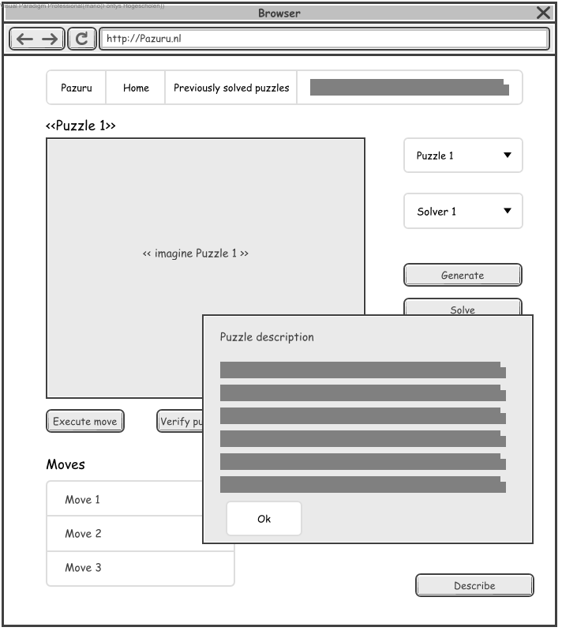

2. SYSTEM Displays a popup that describes the puzzle.

### Show solved puzzles

|  |  |
| --- | --- |
| Show solved puzzles |  |
| ID | UC9 |
| Description | To show the previously solved puzzle list page. |
| Primary Actors | Enigmatologist |
| Level | User |
| Complexity | Low |
| Use Case Status | Complete |
| Implementation Status | Scheduled |
| Preconditions | The ACTOR is on the Home page. |
| Post-conditions | The ACTOR has seen the solved puzzles page. |
| Author | Mario Lucassen |
| Assumptions | N/A |

#### Scenarios

***Happy path***

|  |
| --- |
| 1. The ACTOR clicks on the **Previously solved puzzles** tab. |
| 2. SYSTEM Displays the **Previously solved puzzles** page. |

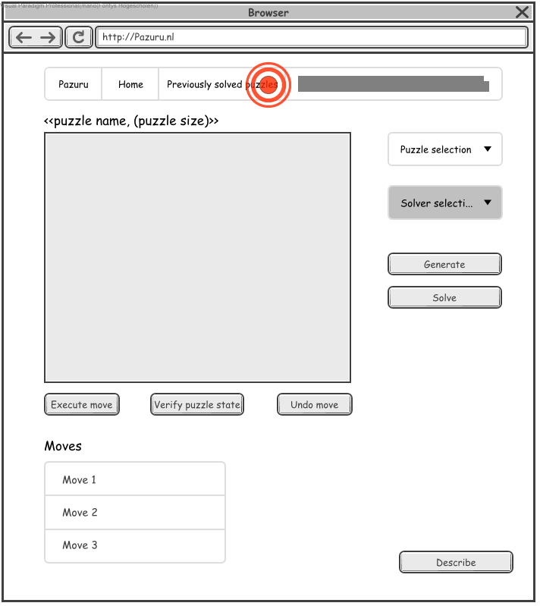

1. The ACTOR clicks on the Previously solved puzzles tab.

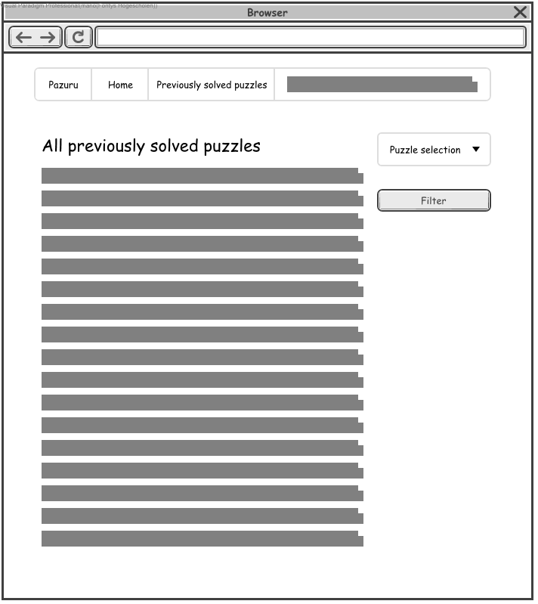

2. SYSTEM Displays the Previously solved puzzles page.

### Filter solved puzzles

|  |  |
| --- | --- |
| Filter solved puzzles |  |
| ID | UC10 |
| Description | To filter the previously solved puzzle list by puzzle type. |
| Primary Actors | Enigmatologist |
| Level | User |
| Complexity | Low |
| Use Case Status | Complete |
| Implementation Status | Scheduled |
| Preconditions | The ACTOR is on the Previously solved puzzles page. |
| Post-conditions | The ACTOR has filtered the solved puzzles list. |
| Author | Mario Lucassen |
| Assumptions | N/A |

#### Scenarios

***Happy path***

|  |
| --- |
| 1. The ACTOR clicks on the puzzle selection. |
| 2. SYSTEM Displays puzzle type list. |
| 3. The ACTOR clicks on the first puzzle. |
| 4. SYSTEM Displays the selected puzzle in the puzzle selection. |
| 5. The ACTOR clicks on the **Filter** button. |
| 6. SYSTEM Filters and only displays solved puzzles from the selected type. |

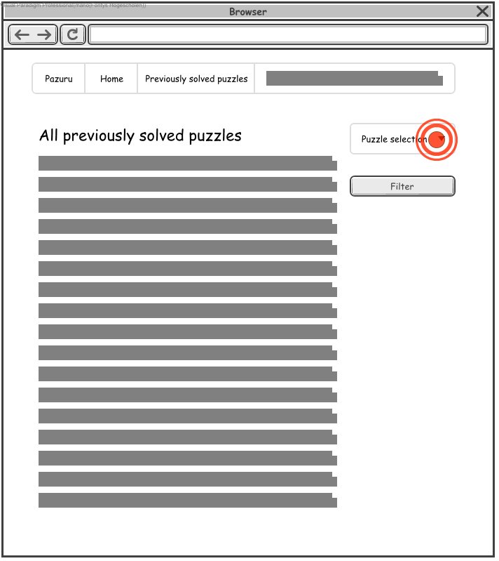

1. The ACTOR clicks on the puzzle selection.

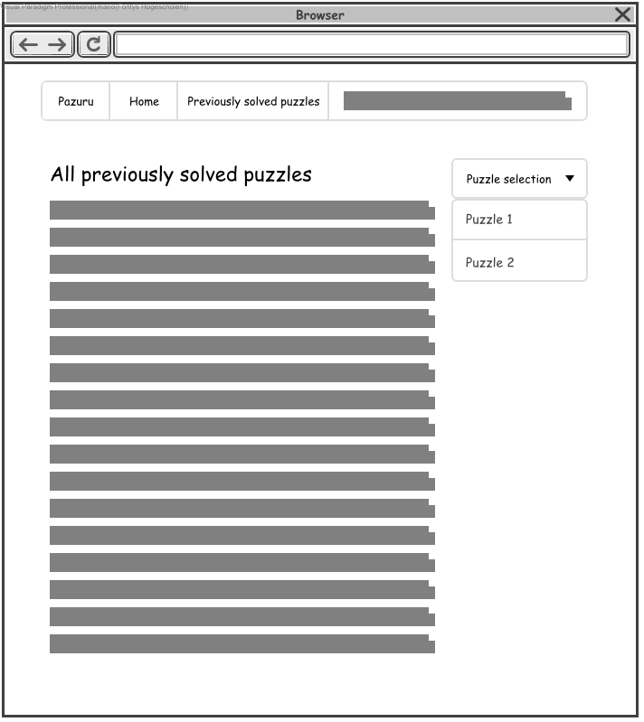

2. SYSTEM Displays puzzle type list.

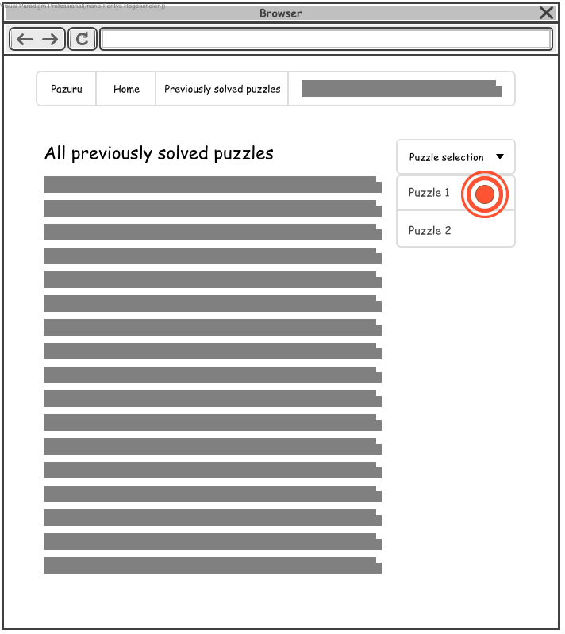

3. The ACTOR clicks on the first puzzle.

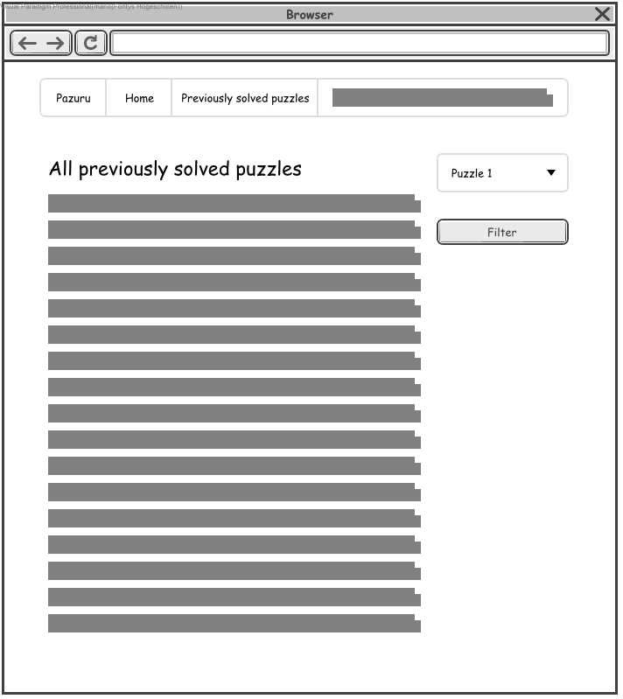

4. SYSTEM Displays the selected puzzle in the puzzle selection.

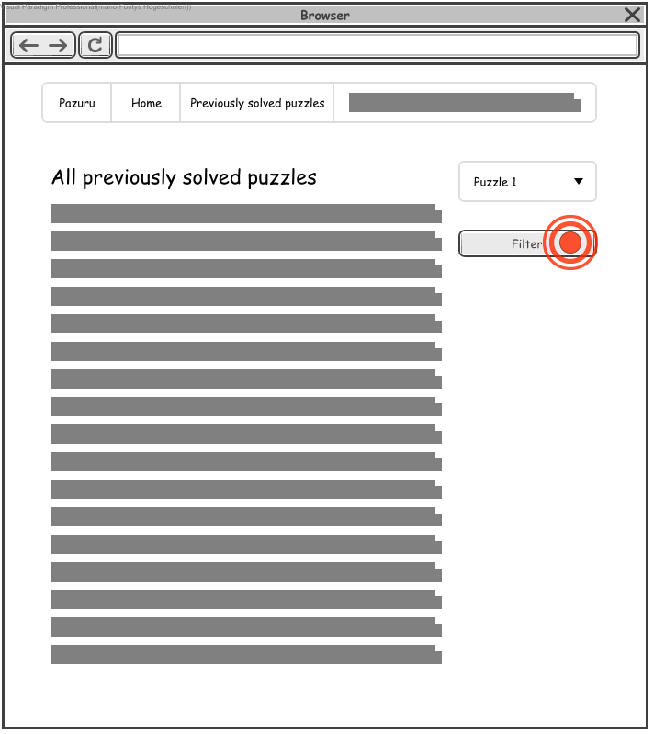

5. The ACTOR clicks on the Filter button.

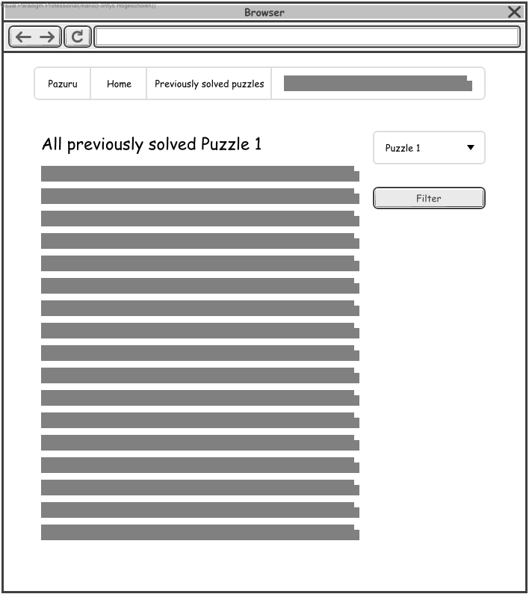

6. SYSTEM Filters and only displays solved puzzles from the selected type.

# User interface specification

This chapter contains the user interface designs. All user interface designs are made with Visual Paradigm wireframe designer.

## Home page

The home page contains the main functionalities as described in chapter 2.1 Actions, F1 to F8.

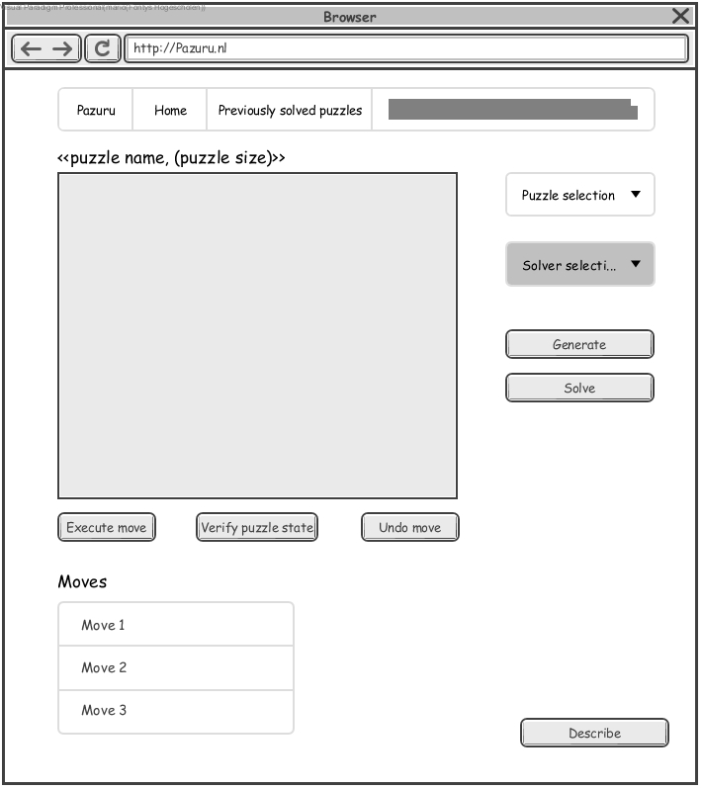

## Previously solved puzzles page

The previously solved puzzles page contains the functionalities as described in chapter 2.1 Actions, F9 to F10.

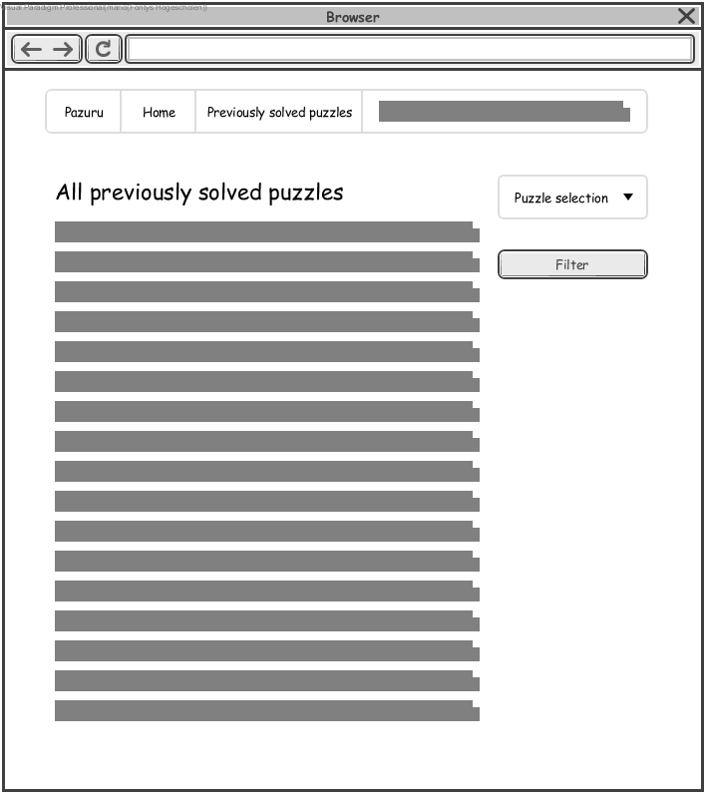

# Architectural analysis

This chapter will give a glance of the system that will be built. This will also be documented in the Software Architecture document but more elaborate.

## System overview

The overall structure of the system being built is shown in the table below.

|  |
| --- |
| Nodes |
| Pazuru Client |
| Pazuru Server |
| Pazuru REST API |



### Client

The client will handle user inputs and send them to the server and receive responses from the server.

### Server

The server will handle all logic for the puzzles, such as executing a puzzle move or generating a new puzzle. The server can communicate with the Client but also with the REST API to store generated and solved puzzles.

### REST API

The REST API its primary use is to store generated and solved puzzles in a database.

## Analysis object model

The Domain model for the system. These classes are derived from the use cases.

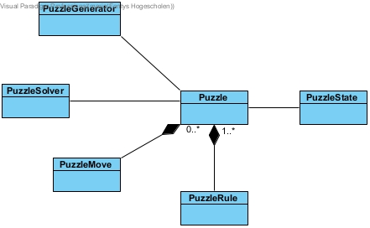

**Explanation**

A puzzle has 1 or more rules, as required by the requirement rules in chapter 2.2 Rules. A puzzle also has a collection of moves for the Move system to execute and undo. A puzzle has 1 PuzzleState to describe the current puzzle state.

1. Author’s name with email address
2. ISO 25010:

   <https://iso25000.com/index.php/en/iso-25000-standards/iso-25010>
3. C# Microsoft Code Conventions:

   <https://docs.microsoft.com/en-us/dotnet/csharp/programming-guide/inside-a-program/coding-conventions>
4. Java Code Conventions:

   <https://www.oracle.com/technetwork/java/codeconventions-150003.pdf>
5. Unified Modeling Language Specification 2.5.1:

   <https://www.omg.org/spec/UML/2.5.1>